Creating a Predictive Model for Housing Price in the UK
Elliott Y. Shi^{1,2}
Lyndsey Harris³
Olivia Harper²
Rahmi Azzahra⁴

Words: 3,649

- Department of Statistics, Purdue University
- Department of Mathematics, Purdue University
- Lyles School of Civil and Construction Engineering, Purdue University
- Department of Food Science, Purdue University

ABSTRACT
Background: The housing market in the past decade has seen a tremendous increase in housing prices. This is a common phenomenon that is universal to most countries around the world. However, housing prices in the United Kingdom (UK) is unique in that it may differ based on regions such as London, Southeast England, and the North.
Methods: Data from the “Housing Prices Dataset”, obtained with Kaggle, with n = 200,000 was used to create a regression-based model that uses the variables in this dataset to predict housing prices. Each of our group members studied a specific subset of variables, with n = 500, and ran our own linear regression model, while performing diagnostics and remedies. In the end, we collated our most important predictors into one final model, where we applied more remedial techniques to produce a finalized and polished model.
Results: For the model regarding property characteristics (variables include property size square footage, number of rooms, constructed year, and decision to buy), the only significant predictor was property size square footage. There were no significant predictors for the model regarding connectivity characteristics (variables include connectivity score, satisfaction score, neighbourhood rating and decision to buy). Meanwhile, the model related to some financial factors, like salary and Emi-to-income show the significant impact on house prices in the UK.
Conclusion: While no model is perfect, by narrowing the scope of what we want to predict and choosing the best variables, the model can be fairly accurate. However, it is important to note that this analysis was conducted in less than a semester, therefore, the model still has some more fine-tuning to do.

BACKGROUND
The general problem with house pricing prediction is that there are many factors that go into how pricing real estate works. Housing prices are economically important as it determines affordability, investment, and policy. Using a statistical modeling approach like running a linear regression model is valuable as it can determine driving forces for increasing prices.
For the scope of this project, we decided to look specifically at houses in the U.K. The reason for this is due to the large strict inequality between different locations, supply constraints, and demographics and income pressures. Like everywhere else in the world, housing prices depend on factors like property size, neighborhood safety, and distance from downtown.
There are many possible determinants of housing prices. For example, within physical characteristics of size, number of rooms, age, and building type (Aliyev et al., 2019). In addition to this, we have that neighborhood safety and location are also important. Findings from Bohman (2021) show that train/subway stations near residential areas have a significant impact on the price of a property. Beyond those factors, we have financial considerations such as income, loan-to-income ratio, and downpayment. In addition, credit constraints may hinder individuals from entering the market since it has possibility to interact with other financial factors that can influence the price of house purchase in UK.
Hedonic pricing theory provides the theoretical foundation for decomposing a house price into contributions from structural characteristics, location, and buyer-related attributes. Empirical hedonic models most commonly use linear or log-linear regression formulations due to skewness.
Due to the abundance of data from Kaggle on housing prices, this topic is needed to be analyzed with different approach of methodologies to narrow down the statistics issues while indicating the impact between variables as factors to outcomes. Hence, this study aims to produce an interpretable regression model while systematically avoiding issues like non-normality in errors, non-linearity, heteroskedasticity, multicollinearity, and outliers to predict house prices in the UK based on related predictors effect.
RESEARCH QUESTIONS
In order to properly allocate the work, each of us formulated and worked on one specific research question within the broader topic. Listed below are each of our separate research questions:
Elliott Shi: Does property size given constructed year, number of rooms, and consumer’s decision to buy impact house price in the UK?
Olivia Harper: Do location characteristics (crime rate and legal cases) and region impact house price in the UK?
Lyndsey Harris: Does connectivity characteristics (connectivity score, satisfaction score, neighbourhood rating, and decision) impact house price in the UK?
Rahmi Azzahra: Do salary, monthly expenses, and EMI burden, significantly predict the price of houses in the UK?
Finally, the final regression model is set to test whether city level differences shape the impact of satisfaction score, property size, and EMI to income ratio on housing prices in the UK.
EXPERIMENT DESIGN
The data of house purchase was obtained online from Kaggle.com, which is a website that contains various different kinds of datasets. Our dataset is the “Housing Prices Dataset” which includes quantitative, qualitative, and binary data regarding characteristics of a property and a consumer’s decision to buy a house. The dataset contains 200,000 observations, which was winnowed down to n = 500 after narrowing it to just the United Kingdom. The observation was taken from the first 500 observations based on property_id, which may introduce possible sampling bias. However, since the study used retroactive data, this would be considered as an observational study.
HYPOTHESIS AND VARIABLES
For each of our individual components, the hypotheses are listed below by using $α$ = 0.05.
Elliott Shi: 𝐻₀: 𝛽_{𝑠𝑖𝑧𝑒}= 𝛽_{𝑠𝑖𝑧𝑒,decision} =0, 𝐻_{𝐴}: At least one of the 𝛽 is not equal to 0
Variables: property_size_sqft, constructed_year, rooms, decision
Lyndsey Harris: H₀: β_{connectivity} = 0 (connectivity score has no effect on house price), H_{A}: β_{connectivity} ≠ 0 (connectivity score does affect house price)
Variables: connectivity_score, satisifaction_score, neighbourhood_rating, decision
Olivia Harper: H₀: β_{crime_cases:city} = β_{legal_cases_on _property:city} = 0. H_{a:} at least one β ≠ 0.
Variables: crime_cases_reported, legal_cases_on_property, and city
Rahmi Azzahra: H₀: β_{customer_salary} = β_{monthly_expenses} = β_{emi_burden} = 0. H_{a:} at least one β ≠ 0.
Variables: customer salary, monthly expenses, and EMI-to-income.
METHODOLOGY AND MODEL BUILDING PROCESS
The analysis in this study followed the model-building pipeline from exploratory analysis, initial linear model, diagnostics, remedial techniques, model refinement, and integration of key predictors into a final combined model. Using the variables above, the initial regression model is decided and created individually, by each of group member, who checked the models’ criteria for non-linearity, heteroskedasticity, multicollinearity, normality of errors, outliers and influential points. Each model was created to see whether a group of factors influences house price. After that, for each model the dataset was cleaned, outliers removed, considered transformations to improve the data, and created interaction terms. Exploratory data analysis was done to see what variables appear most related to price, are the relationships linear, and are there any skewed distributions. Then, a full model was created with predictors and interaction terms based on model selection strategies; from there, an improved model would be created to address any problems in each model.
Lyndsey – For the model containing characteristics of connectivity, the main predictors were connectivity_score, satisfaction_score, neighbourhood_rating, and decision. The two interaction terms (connectivity_score*neighbourhood_rating and connectivity_score*decision) were included whether to test the impact of connectivity varies by neighbourhood rating and the impact of connectivity varies by buyer decision. Before modeling, descriptive statistical and correlations were applied. The correlations between predictors and price were very weak (the r-values close to zero) and exploratory plots showed a few extreme price values. Scatterplots didn’t show a strong linear relationship between connectivity, the price histogram appears fairly uniform, and price and boxplots showed potential outliers (Appendix L, Figures 1-3). Therefore, a linear regression model using price was fitted as the outcome. R output showed several issues: normality – the QQ plot showed heavy tails, and the Shapiro-Wilk test confirmed non-normal residuals (p = 9.07e-11), homoscedasticity – the Breusch-Pagan test gave p = 0.168, so there was no strong evidence of heteroscedasticity, but the residuals were very large (±£1M), and influential points – Cook's distance and leverage plots identified observations above common thresholds, meaning some points had a bug impact on the model (Appendix L, Figures 4-9).
The initial model explained almost none of the variation in price (R² = 0.011), and none of the predictors or interactions were statistically significant (all p-values > 0.05). Due to these issues, non-normality, extreme residual spread, and influential points, the remedy of a log transformation was applied to price, and high influence observations was removed to improve model performance and assumption checks.
Elliott – After conducting exploratory data analysis on size, constructed year, number of rooms, and decision, I fit an initial model using those parameters to predict housing price. The histograms of my predictors can be found in (Appendix E, Figures 1-4). Afterwards, I obtained the residuals and fitted values using the resid() and fitted() commands in R. I then plotted my residuals vs. fitted graph and partial regression plots to get a first glance understanding of the relationship between my predictors and the response variable (Appendix E, Figure 5-6). To diagnose the model, I used the Breusch-Pagan test in R (bptest()) to evaluate heteroskedasticity. Similarly, I plotted the histogram of the residuals of my model to check for normality as well as the Shapiro test (Appendix E, Figure 7). A VIF test was then used to check if any pair of variables were highly collinear. Lastly, I check outliers and influential points by using appropriate thresholds.
From my diagnostic tests, I found that my predictors were linear, errors had constant variance (Breush-Pagan p = 0.6152), and no indication of severe multicollinearity (All VIFs < 10). However, according to my plots, there were a lot of outliers and influential points, as well as non-normal errors from the histogram, QQPlot, and a Shapiro p = $3.912 ×{10}^{-8}$. (Appendix E, Figures 8-9). To address this, I first removed points that were outside of the 1.5*(IQR) range, as this will reduce the number of outliers and potentially help with obtaining normal errors. This remedy helped with reducing the number of outliers as well as a slightly straighter QQplot.
Olivia- For the model looking at location characteristics the following predictors were chosen: crime_cases_reported, legal_cases_on_property, and city (interaction), with price as the response variable. Preliminary exploratory plots were produced to identify any early patterns or concerns (Appendix O, Figures 1-4). At this point I observed that while crime_cases_reported is technically continuous, it behaves more like a categorical variable since no more than four crimes were reported for any observation. An initial model was fitted that displayed the scatterplot, QQ-plot and histogram shown in Appendix O, Figures 5-7. The scatterplot showed no non-linearity or heteroscedasticity (BP p=0.8482), although the categorical nature of the predictors can be seen in the plot. The QQ-plot and histogram do potential outliers and non-normality which was confirmed with a Shapiro-Wilk p-value of $6.99×{10}^{-10}$. Following that, tests were completed to specifically check for influential points and outliers. Serval points were identified (Appendix O, Figures 8-9), so I tried removing outliers that were outside of the 1.5*IQR range, however upon re-running the diagnostic tests I found that almost all legal_cases = 1 observations were removed. So, after considering the tradeoff of losing those points or including outliers, I decided to not remove outliers and let any corrections be carried out through a weighted least squares regression. Lastly, a VIF test was used to diagnose multicollinearity which found that all predictors had a VIF > 5 indicating concerning or severe multicollinearity, addressed in results section. In summary, diagnostic tests revealed multicollinearity and non-normal residual distributions which aim to be addressed through Weighted Least Squares Regression and Ridge Regression.
Rahmi- After data collection and load, the conversion was applied to categorize variables to factors and to remove rows with missing values for 3 chosen predictors, which obtained from the first 500 observations data of house purchase in the UK. The primary predictor is costumer salary, and other correlated predictors are monthly expenses, and EMI to income ratio. Before observing data distribution, the missing values data was accounted. Data distribution, histogram, mean, and standard deviation on each predictor were analyzed to assist the observation on how the predictors can be a potential influence on house prices in the UK. Then, descriptive statistics analysis is conducted, following by QQ plot, Breusch-Pagan test, Shapiro-Wills test, Leverage, and Cook’s distances to diagnose the model m4. When most output show non-normality issues, heteroscedasticity, and multicollinearity, the model improvement was addressed to remedy using suitable formula methodologies, for instance log(price) or log(y) transformation and robust regressions. After their output analyzed, back transformation of log(y) and bootstrapping were implemented. Finally, classical statistical tests were conducted to test Hypothesis null and alternative. The baseline of full model (m4) was built with a formula:
Price_{i =} β₀ +β₁ (Salary_{i} )+β₂ (Monthly_Expenses_{i} )+β₃ (EMI_to_Income_{i} )+ε_{i} .
The transformed model of log Y indicated by:
log(price) ~ customer_salary + monthly_expenses + emi_to_income_ratio
Whereas model for robust regression of Huber:
price ~ (c_customer_salary + c_monthly_expenses + c_emi_to_income_ratio)²
The “c” alphabet indicating centered variables to improve output clarity after running the data analysis. It was started from the interaction model between related predictors to check whether or not the interaction added value. Then, the output will be compared using ANOVA F-nested, AIC, and BIC tests before implementing remedies.
Full Model: To create a full model, we combined all predictors across all individual models into a single model and conducted model selection criterion. After comparing R-squared, Adjusted R-squared, AIC, BIC, Cp, and PRESS methods it was decided to follow the Adjusted R-Squared model which is used for prediction and was the least restrictive on predictiors. The decision gave us the following predictors: property_size_sqft, satisfaction_score, emi_to_income_ratio, and city (interaction), which we combined into the following model:
price∼property_size_sqft+satisfaction_score+emi_to_income_ratio+property_size_sqft×city+satisfaction_score×city+emi_to_income_ratio×city
Assessment of the scatterplots, histogram, and QQ Plot of the residuals (Appendix F, Figures 1-3), the Shapiro-Wilk test, Breusch-Pagan test, and VIF test, and the model summary reveals no non-linearity, no heteroscedasticity (BP p=0.9386), a normality issue (S-W p=$5.527×{10}^{-10}$) and a multicollinearity issue with property size, satisfaction score, and property size: Manchester having significant p-values (Appendix F, Figure 4). Plots of Cook’s Distance and Leverage values (Appendix F, Figure 5) highlight potential outliers and influential points prompting us to refit the model with a dataset with outliers outside 1.5*IQR removed. Adjusted Shapiro-Wilk test has a p-value of $4.1252×{10}^{-7}$ which is larger than the original model, but still indicates non-normal residuals, so further remedial methods should be used.

RESULTS
Lyndsey – To fix these violations of model assumptions, the price variable was log-transformed, the model was re-fitted, however the predictors were still statistically insignificant. Cook’s distance (cutoff was 4/(n-k-1)) was used to remove about thirty influential observations which gave a lower residual error. This model included interaction terms so generalized VIFs (GVIFS) were examined, and the interaction terms (connectivity_score*neighbourhood_rating and connectivity_score*decision) were centered to mitigate multicollinearity. After these adjustments, diagnostic test indicated that assumptions were reasonably met. The Breusch-Pagan test gave a p-value of 0.09836, suggesting not strong evidence of heteroscedasticity. However, the Shapiro-Wilk test gave a p-value of 3.511e-4, which is below 0.05, still indicating residuals deviate from normality. But since there is a large sample size, this matters a lot less because the Central Limit Theorem helps stabilize the inference. Overall, the final model showed improved fit and assumptions were reasonably met (Appendix L, Figures 10-14).
Elliott – After cleaning the dataset, I fit a Robust regression using Tukey’s biweights to downweight the residuals aggressively. This helped with the reduction of outliers and influential points as can be seen in Appendix E, Figure 10-11. However, there still seems to be a problem with non-normal errors, that I wasn’t able to fully get rid of. Testing for non-linearity, heteroskedasticity, and multicollinearity, showed that there still aren’t any violations for these conditions. Because robust regression doesn’t support classical F-tests, I performed anova on the regular linear models, while final coefficient estimates are based on robust regression. The anova output and coefficients are in Appendix E, Figures 12-13. From the ANOVA output, we have that our F statistic is significant and therefore this study provides evidence at the .05 significance level that property size has an impact on housing price given number of rooms and constructed year. Looking at the robust regression output, we can see that property size when the consumer doesn’t buy the house is the only significant predictor with a t-value of 2655.
Olivia – To address non-normality diagnosed in the methods section, I fit a Weighted Least Squares model to minimize the sum of squared residuals. A revised Shapiro-Wilk test and new histograms and scatterplots showed little improvement to the normality issue (Shapiro p= $6.482×{10}^{-10}$(Appendix O, Figure 10). However, intuition indicates that multicollinearity is too strong and the cities given are too similar in crime rate and socioeconomic status, that remedies overall would have no effect on significance. Regardless, a WLS Bootstrapped confidence intervals were constructed. In comparison with a t-based CI, bootstrapped CIs were similar, but slightly narrower. All confidence intervals contained 0, except for the intercept, so after WLS Regression city does not appear to have an effect on any predictor (Appendix O, Figure 11). Next a Ridge Regression was performed to combat multicollinearity. The confidence intervals produced were very similar to the WLS CIs, the only intercept gave a significant confidence interval, and any of the confidence intervals overlap indicating that impacts many not be statistically significant (Appendix O, Figure 12). Lastly to actually test the hypothesis I performed an Anova test (see Appendix O, Figure 13) and obtained the same result that the WLS and Ridge confidence intervals produced: there are no overall regional effects for the model chosen. This is likely due to the fact that Birmingham, Liverpool, London, and Manchester are all large cities in the UK in similar economic standing, so price and crime would be very similar across the four cities.
Rahmi – From statistics descriptive analysis of model m4 (APENDIX R, Figure 2, it presents about 37% of the variation in UK house prices (Adjusted R² = 0.3696) within a highly significant overall (F = 98.52, p < 2.2^{‑16}). Among predictors, customer salary (Estimate ≈ 10.47, p < 0.001) and EMI-to-income ratio (estimate ≈ 3,026,000, p < 0.001) are strong positive predictors of house price, indicating that higher income and higher EMI burden are associated with more expensive properties. Monthly expenses show a negative coefficient but are not statistically significant (p ≈ 0.425), suggesting less independent effect after controlling for salary and EMI ratio. Residuals range widely, implying other factors (e.g., location, property type) also influence price. However, VIFs values for the three predictors were around 1.1-1.3 (less than 5), indicating no multicollinearity issues. Since, the issues occurred on non-linearity, non-normality on residuals, and heteroscedasticity, the remedies are strongly emphasis on log(y) transformation, and robust regressions (both Huber and SE). After log(y) transformation, BP test output showed a significant change of p‑value, from < 2.2e⁻¹⁶ (base model) to 0.283 (log model).
Full Model: After completing diagnostic testing, we ran a Weighted Least Squares regression model to help continue minimizing the normality issue. After fitting the model the Shapiro-Wilk p-value significantly increased while also showing similar summary results to the original model (i.e. property size is still significant). To apply interpretability, we construct bootstrapped confidence intervals (Appendix F, Figure 6) which show that Property size as well as EMI ratio with Manchester were significant. This matches what was highlighted in the initial model. Our second remedy is a Ridge Regression model using the weights computed in the WLS remedy to account for multicollinearity. Confidence intervals only indicate property size as significant which further confirms that property size is a strong predictor for price (Appendix F, Figure 7). Finally, we run an ANOVA model to test our hypothesis on whether city level effects shape our predictor’s effects on price. We obtain the output shown in Appendix F, Figure 8. Since our p-value (0.0046) is less that 0.05 we can reject the null and conclude there are city level differences. This makes sense especially in comparison to the location characteristics. Intuitively and through what has been shown here, property size is probably the best indicator for predictive price, so because it already has a significant effect, it would likely be more sensitive to smaller differences (city differences) than something that has little predictive influence on price.

DISCUSSION
Elliott – Since my ANOVA test proved significant, we can reject the null hypothesis and conclude that property size does have a significant impact on housing price given number of rooms, constructed age, and decision. I have that for every 1 additional square footage corresponds to approximately a 399.95-unit price increase.
Lyndsey – The hypothesis tested was: H₀: β_{connectivity} = 0 (connectivity score has no effect on house price), H_{A}: β_{connectivity} ≠ 0 (connectivity score does affect house price). From the log-transformed model output: The estimated coefficient for connectivity score is ~0.01596, which suggests a small positive effect however the p-value = 0.160 which is above the α = 0.05 threshold. The overall model fit remains weak and the F-test is non-significant (p = 0.5231). Assumption checks improved after centering and cleaning; Breusch-Pagan (p = 0.09836) showed no strong evidence of heteroscedasticity and Shapiro-Wilk (p = 3.51e-14) showed the residuals are still not completely normal but its less important for inference in large samples. So, we fail to reject H₀ because there is no statistically significant evidence that connectivity score affects house price in this dataset.
Olivia – My ANOVA test assessing whether there were any overall city effects on a model predicting price from crime reports and legal cases did not have a significant p-value so we reject the hypothesis that there are any city effects. As previously mentioned, this makes sense since the city levels are four large cities in the UK with similar economic and demographic factors.
Rahmi - Robust to outliers and high leverage with Robust (Huber) showed output downweighs large residuals, so influential points do not dominate the fit. Huber robust regression on log(price) is a good remedy for outliers and heavy‑tailed residuals, especially since Breusch–Pagan test improved (variance is now stable on the log scale). Modeled log(y) stabilized variance (BP p = 0.283), that means heteroscedasticity is no longer an issue on the log scale. Because residuals exhibited heavy tails and influential points, fitted Huber robust regression (MASS::rlm) downweighs outliers. The robust fit confirmed salary, EMI ratio, and their interaction as the principal drivers of log(y), but monthly expenses effects were small. For inference, robust standard errors on the log‑OLS model were reported for prediction. The back‑transformed fits using smearing for both models and compare errors. Therefore, hypothesis null is rejected, meaning there is significant effect from financial factors, especially EMI-to-income ratio, to predict house prices in the UK. Conclusions are consistent across remedies.
Full Model – According to our ANOVA model, we reject the null hypothesis and conclude that there are city level differences (Appendix F, Figure 8). In other words, cities in the UK such as London, Manchester, Birmingham, and Liverpool have significant differences in housing prices. This is exactly what we would expect; not just in the UK, but like everywhere else in the world. Using criterion like $R_{adj}^{2}$, AIC, BIC, PRESS, etc are all important when it comes down to winnowing down predictors. Additionally, diagnostics serves an important role in determining model choice.
One limitation of this project is that we were unable to consider every potential variable due to timing constraints. If we had more time, we would have examined more potential variables that could lead to deeper insights. Another limitation is that this dataset is inherently highly multicollinear, leading to a lot of our analyses succumb through strict remedial processes. Despite all this, we were able to develop robust and accurate models that we are happy to present.

APPENDIX E
Figure 1. Histogram of Property Size
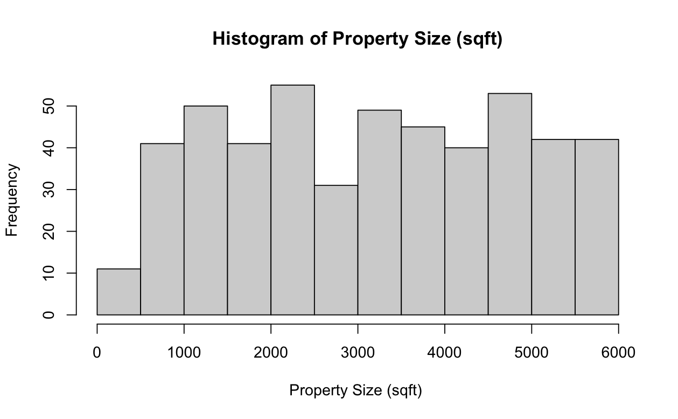
Figure 2. Histogram of Constructed Year
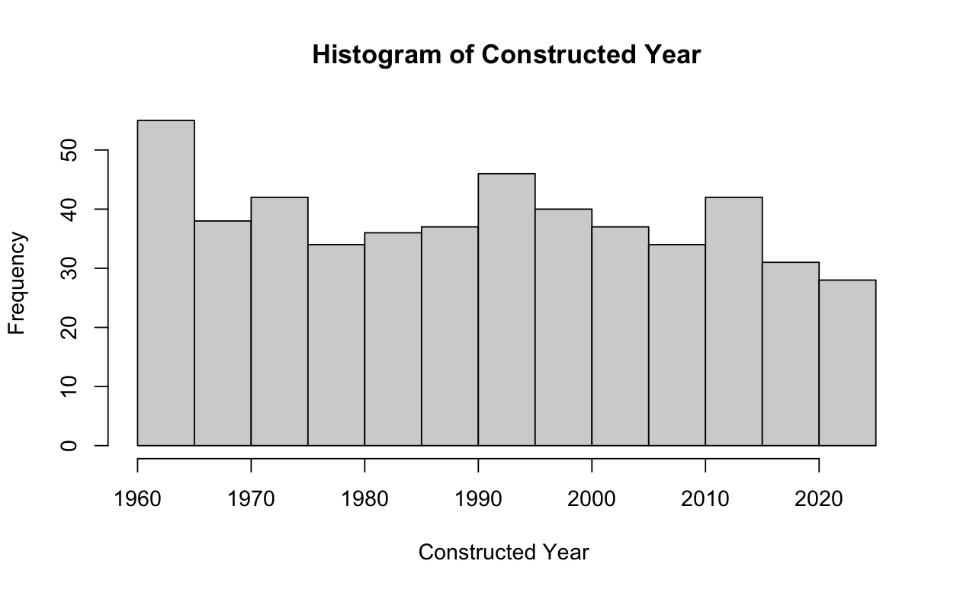
Figure 3. Histogram of Number of Rooms
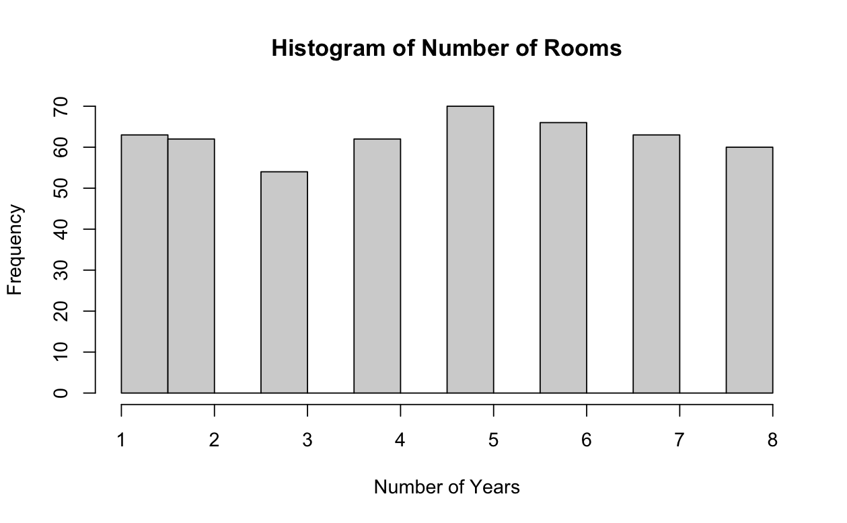
Figure 4. Histogram of Decision
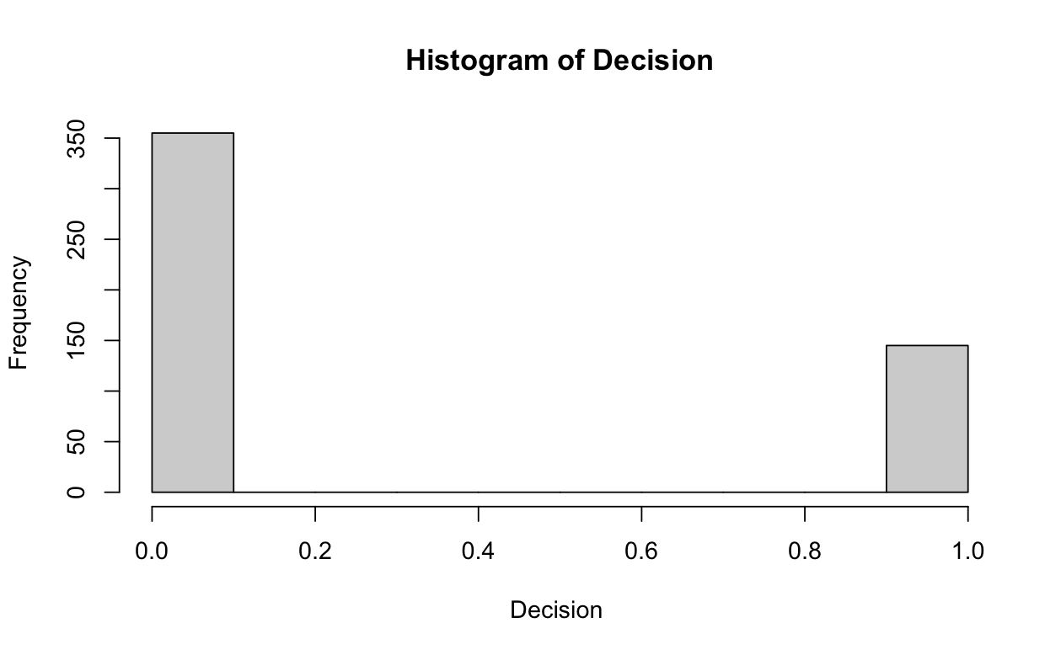
Figure 5. Residuals vs Fitted for Property Characteristics
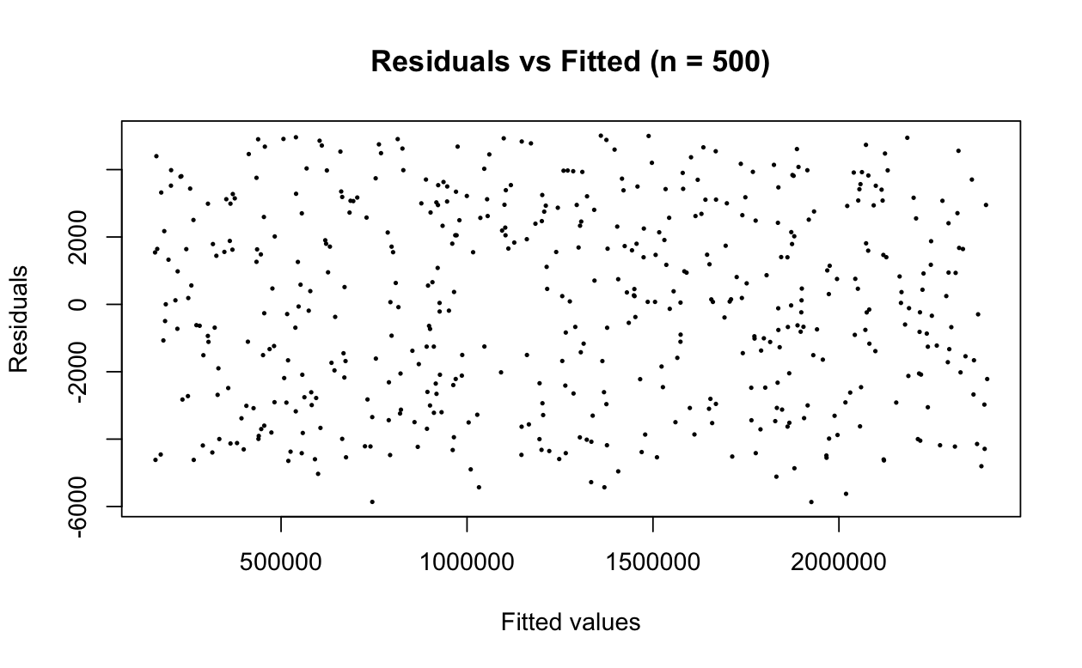Figure 6. Partial-Regression Plots for Property Characteristics
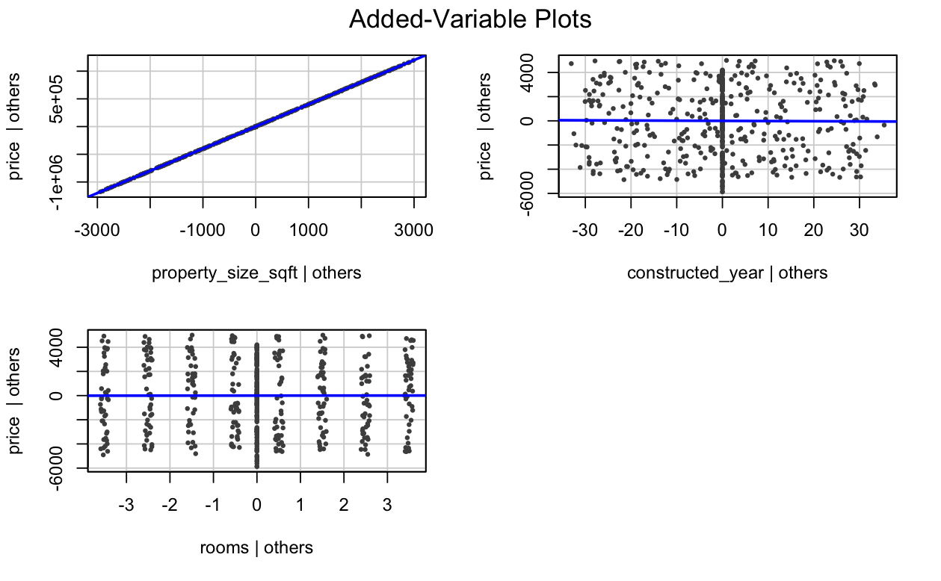
Figures 7. Histogram of Residuals
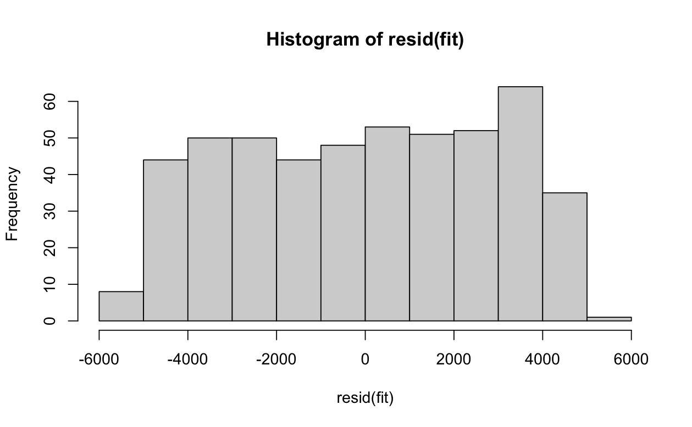Figure 8. QQPlot for Property Characteristics
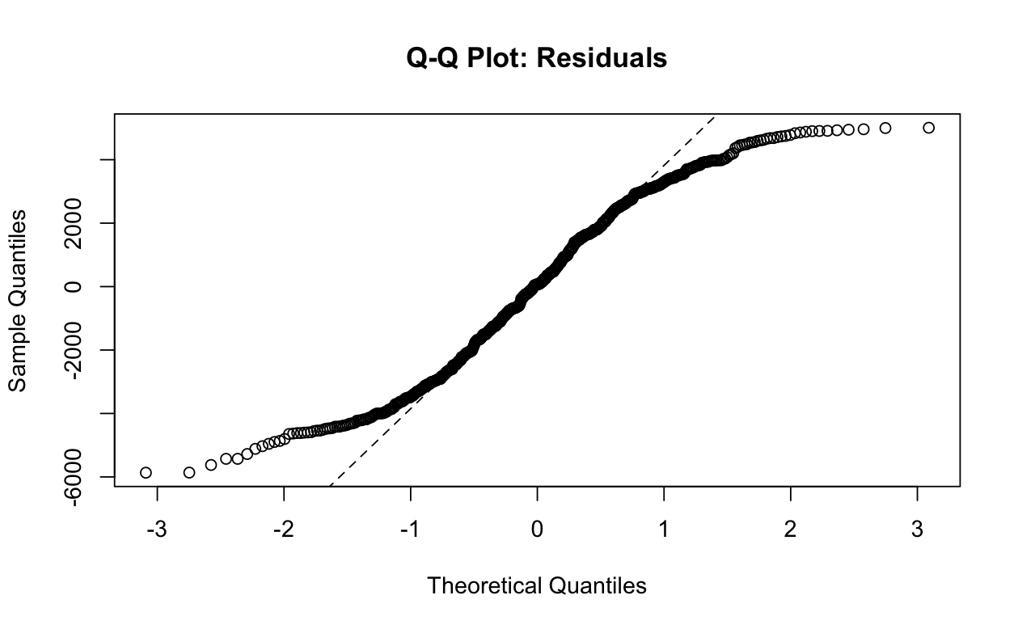Figure 9. Outliers and Influential Points for Property Characteristics
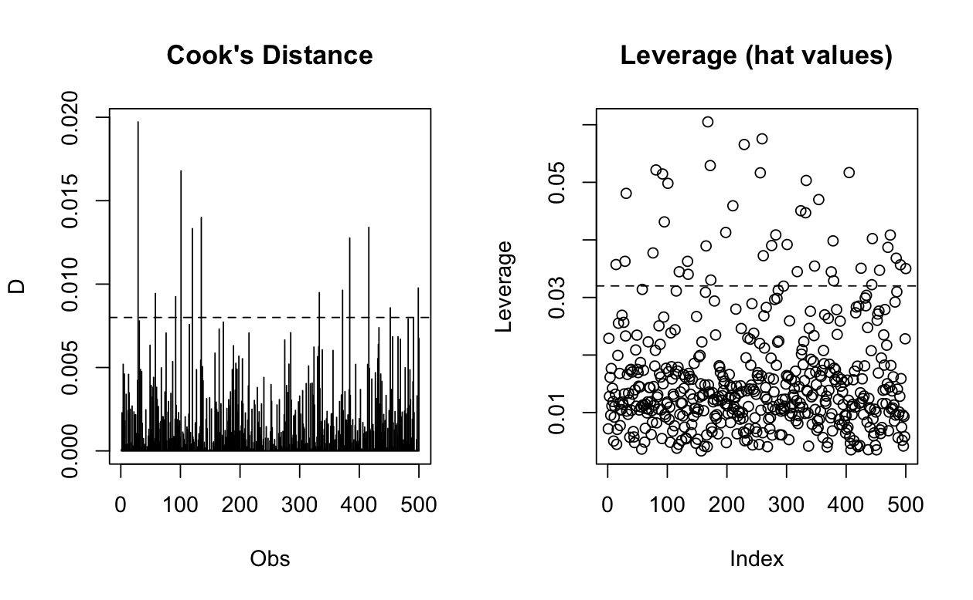
Figure 10. Remedied QQplot for Property Characteristics
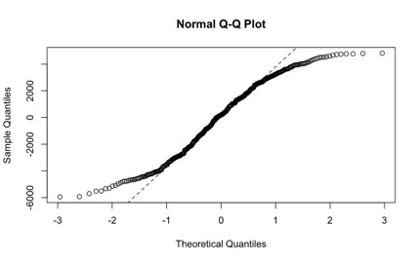
Figure 11. Remedied Outliers and Influential Points for Property Characteristics
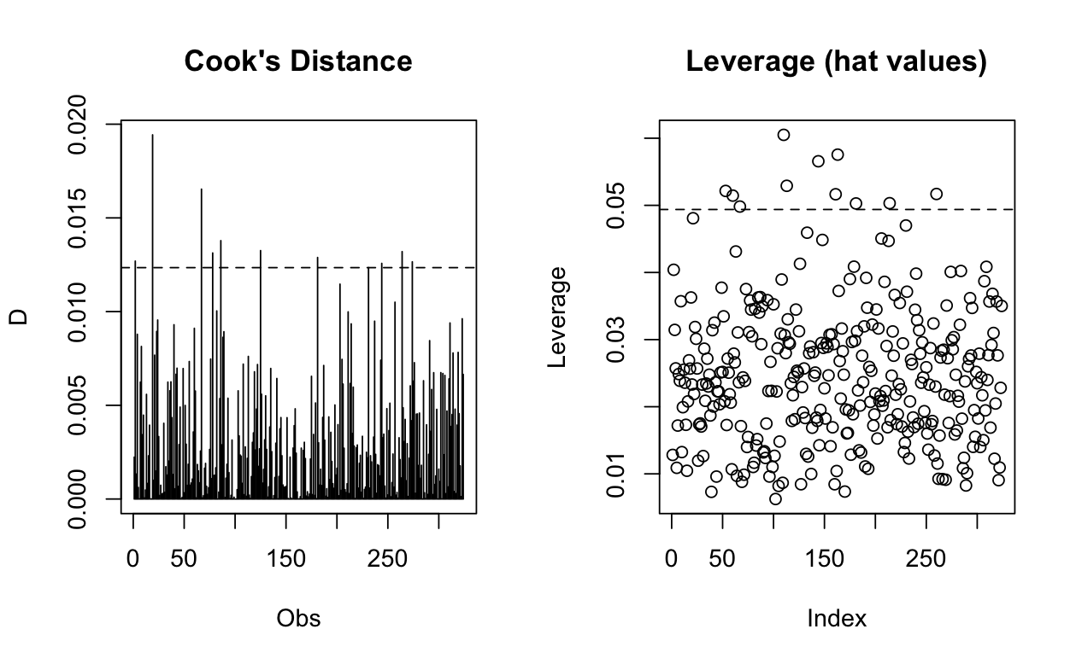
Figure 12. ANOVA Table for Property Characteristics
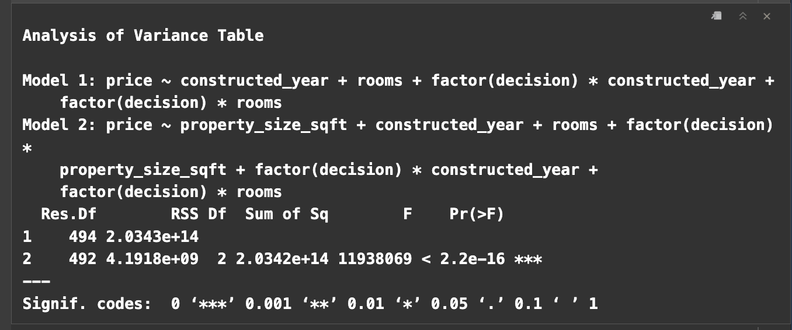Figure 13. Robust Regression Coefficients for Property Characteristics
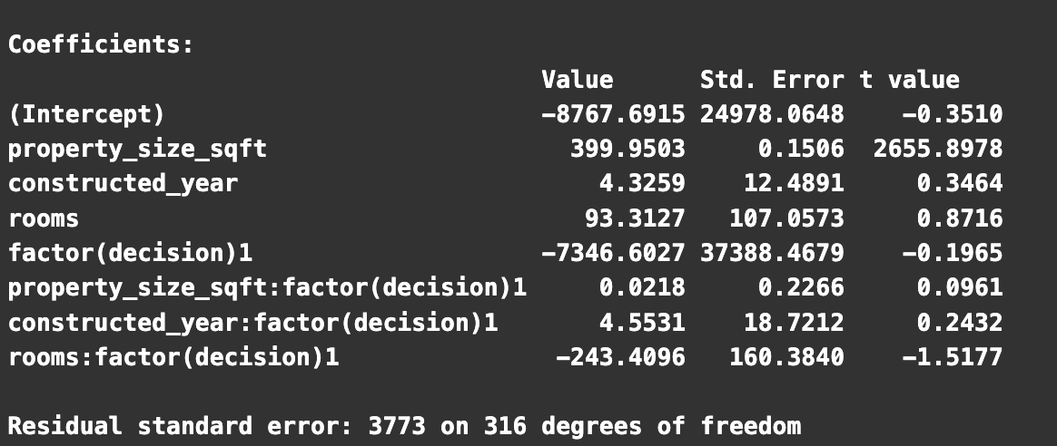
APPENDIX L
Figure 1: Distribution of House Prices
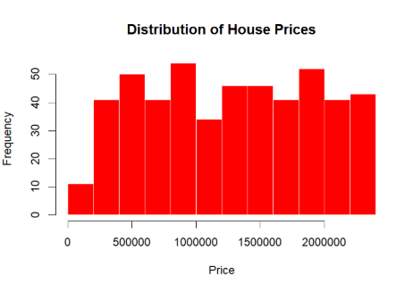
Figure 2: Connectivity Score vs House Price
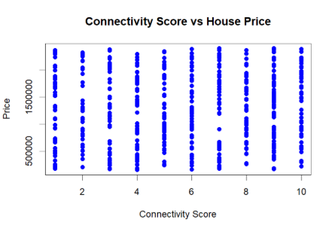
Figure 3: Price by Neighbourhood Ratings
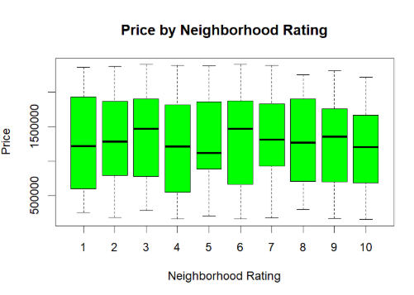
Figure 4: Residuals vs Fitted Plot
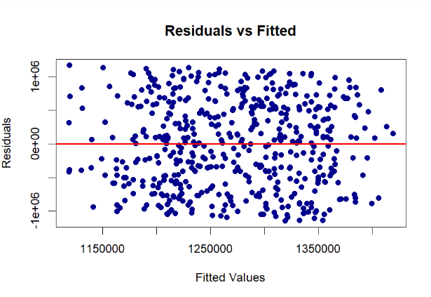
Figure 5: Added-variable Plots
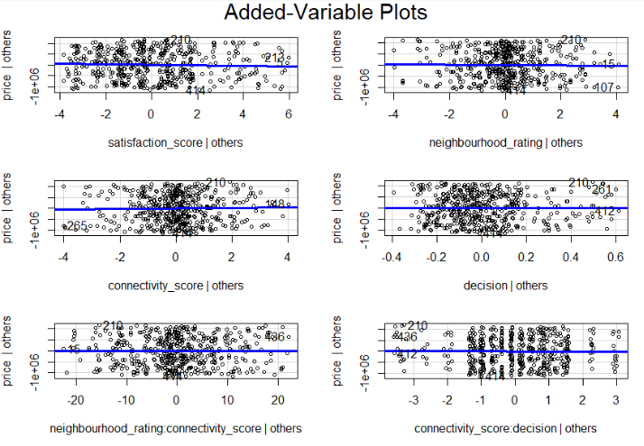
Figure 6: Histogram of Residuals
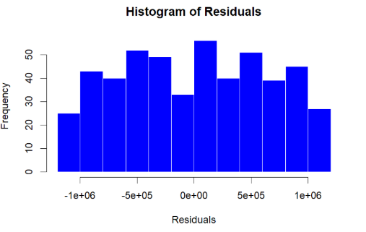
Figure 7: Normal QQ Plot
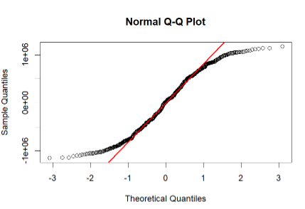
Figure 8: Cook’s Distance
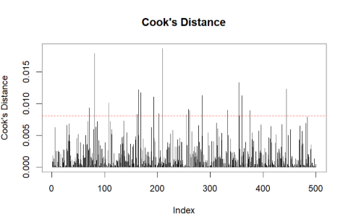
Figure 9: Leverage Values
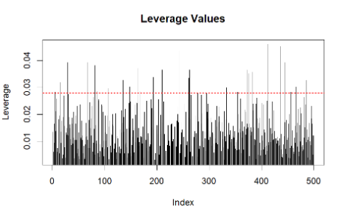
Figure 10: Updated Residuals vs Fitted Plot
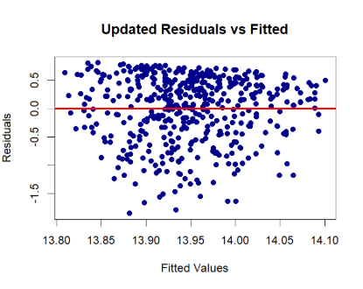
Figure 11: Updated Histogram of Residuals
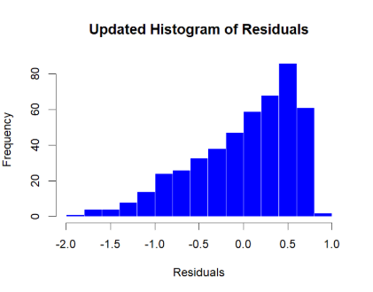
Figure 12: Updated QQ Plot
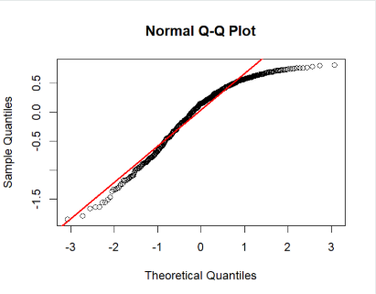
Figure 13: Updated Cook’s Distance
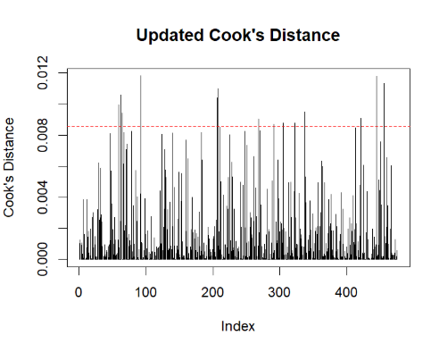
Figure 14: Updated Leverage Values
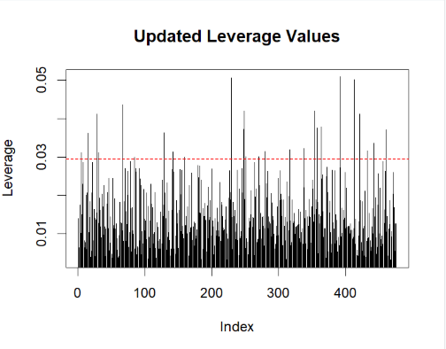

APPENDIX O
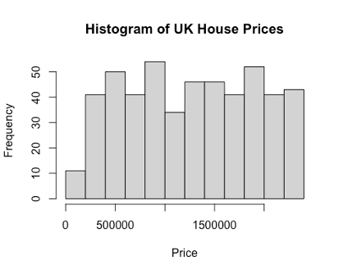
Figure 1: Histogram of UK house prices
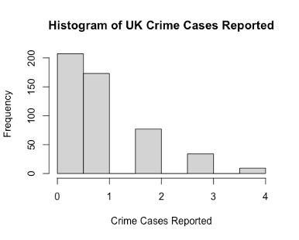
Figure 2: Histogram of Crime Cases Reported
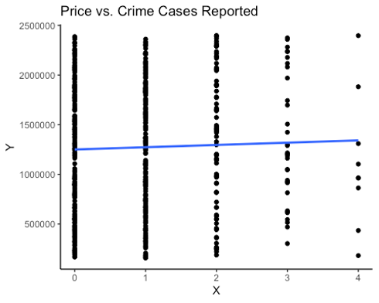
Figure 3: Scatterplot of Price vs. Crime cases
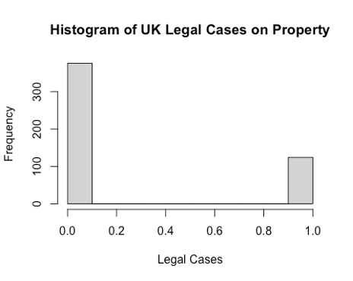
Figure 4: Histogram of Legal Cases on Property
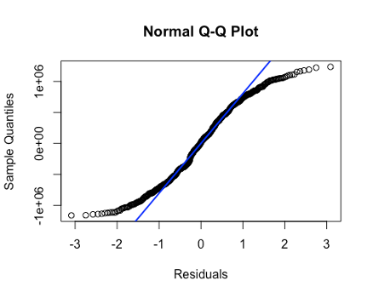
Figure 5: QQ Plot for Residuals of original model
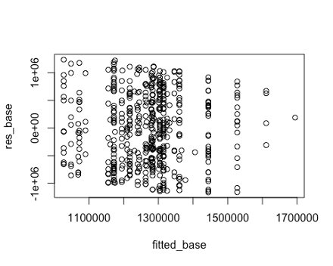
Figure 6: Residuals vs. Fitted scatterplot for original model
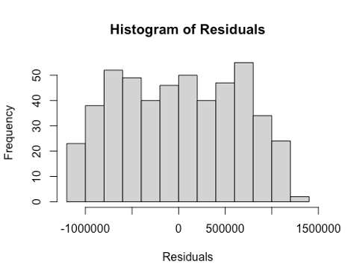
Figure 7: Histogram of residuals for original model
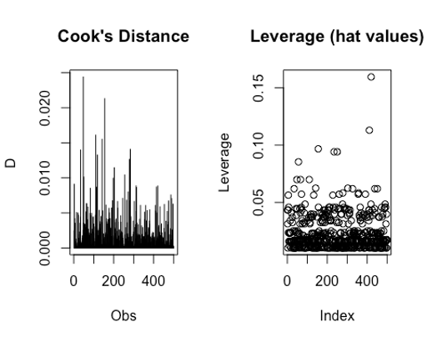
Figure 8: Cook’s Distance plot and Leverage Plot
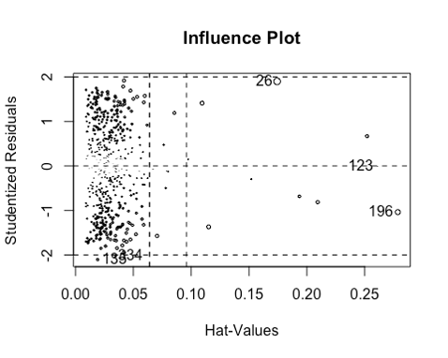
Figure 9: Leverage Plot
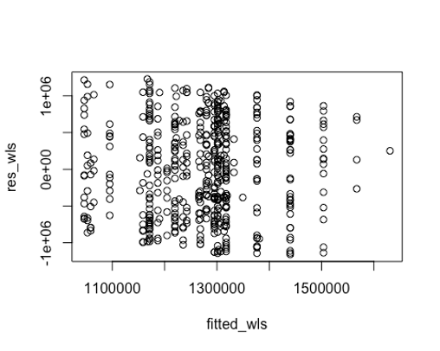
Figure 10: Residuals vs. Fitted scatterplot for WLS model 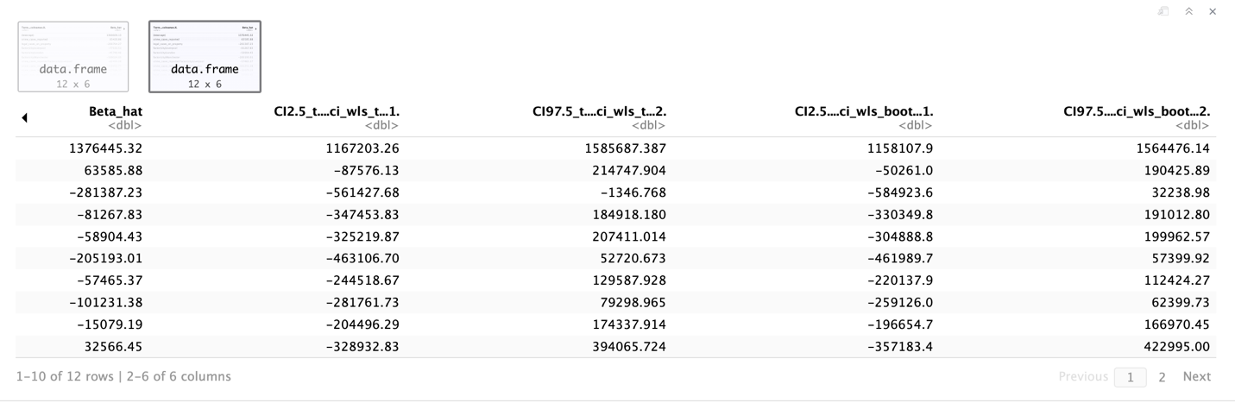Figure 11: WLS bootstrapped and t-based confidence intervals
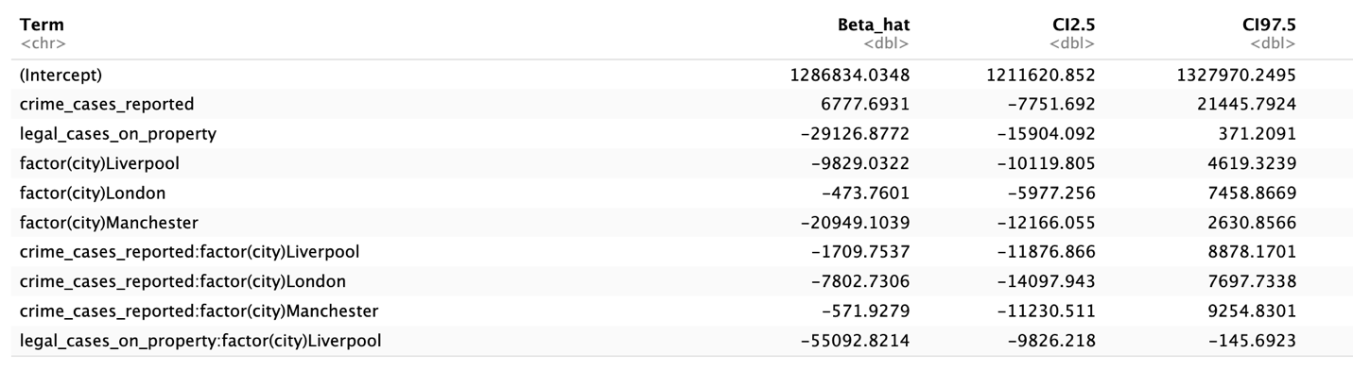Figure 12: Ridge Regression bootstrapped confidence intervals
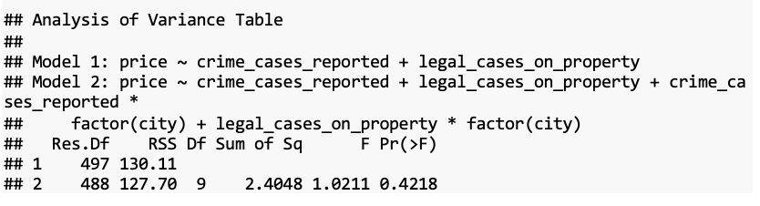
Figure 13: ANOVA output for overall regional effects

APPENDIX R
Figure 1. Histogram of Customer Salary, Emi-to-income Ratio, and Monthly Expanses
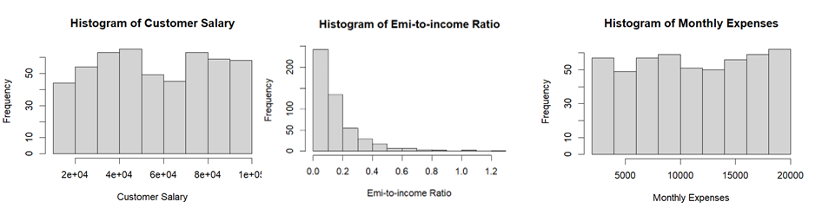Figure 2. Descriptive statistics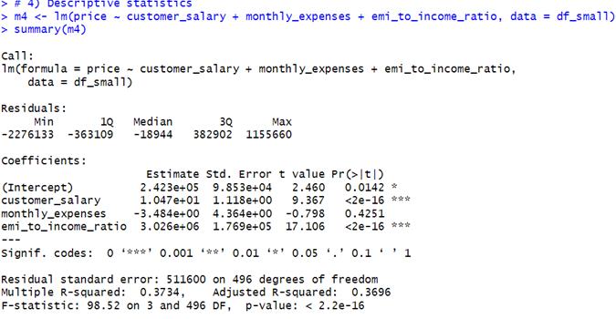
Figure 3. Added-variable plots and Residual vs. Fitted plot
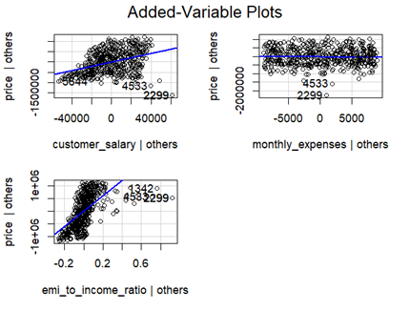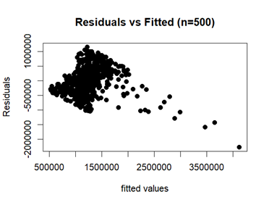
Figure 4. QQ Plot, Leverage and Cook’s Distance plots
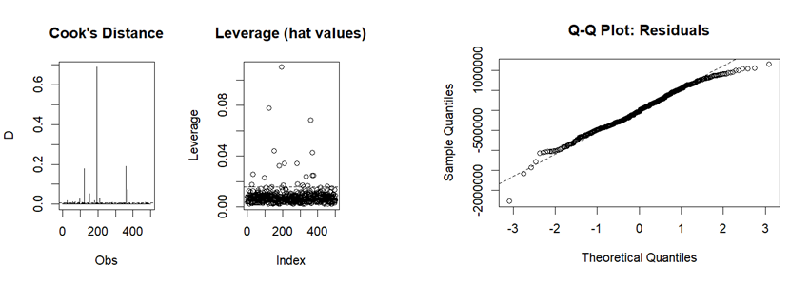

Figure 5. Residual plot
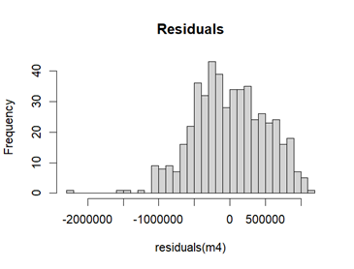
Figure 6. Anova F-test, AIC, BIC
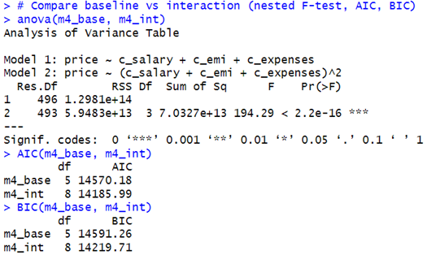
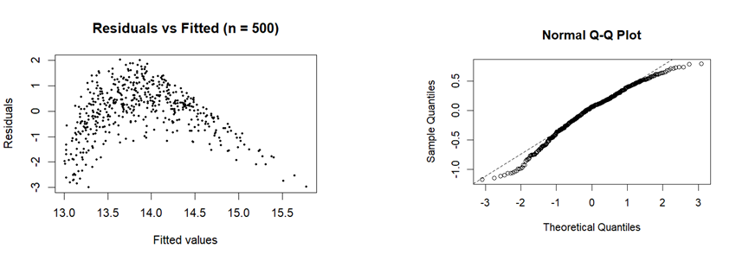
Figure 7. Updated figures after log(y) transformed

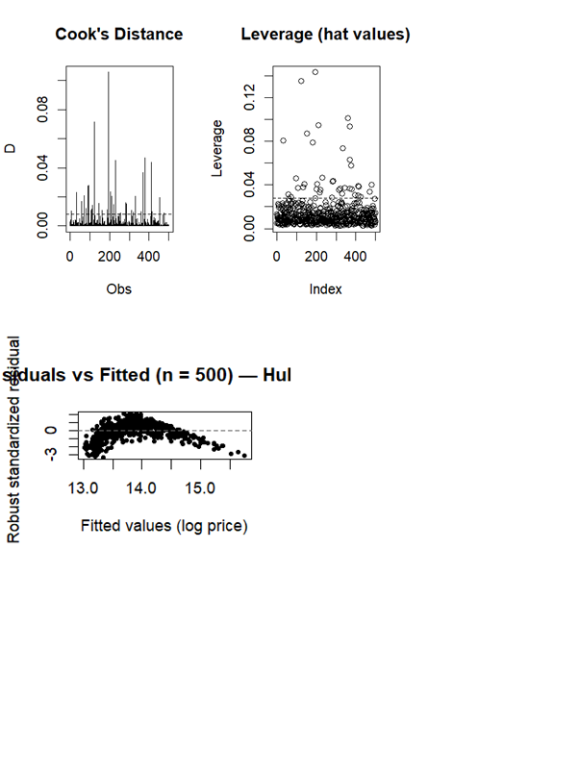
Figure 8. Updated figure for Leverage and Cook’s Distance after log(y) transformed

Figure 9. Formula used

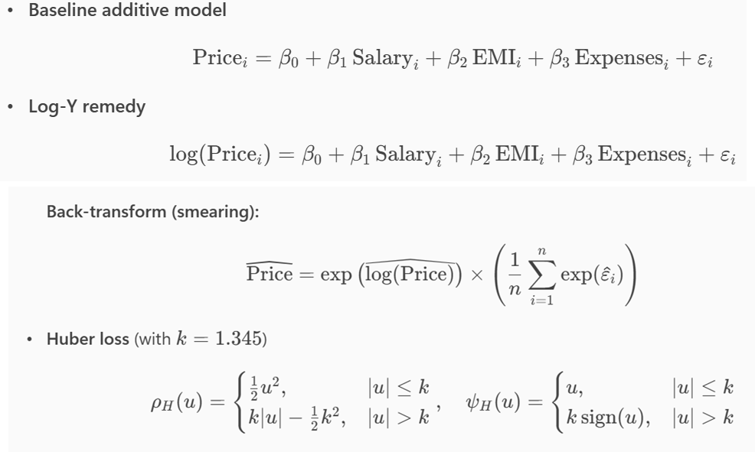

APPENDIX F
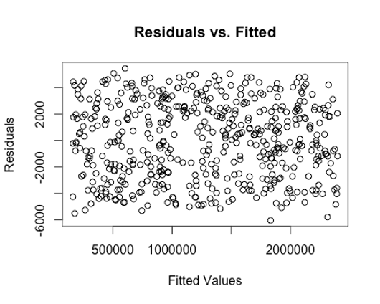
Figure 1: Combined Model Residual vs. Fitted Values Scatterplot
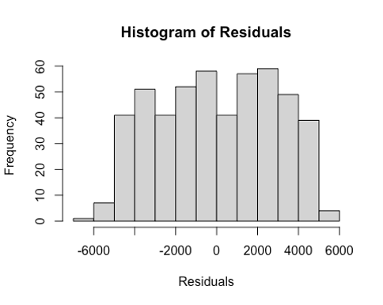
Figure 2: Combined Model Histogram of Residuals
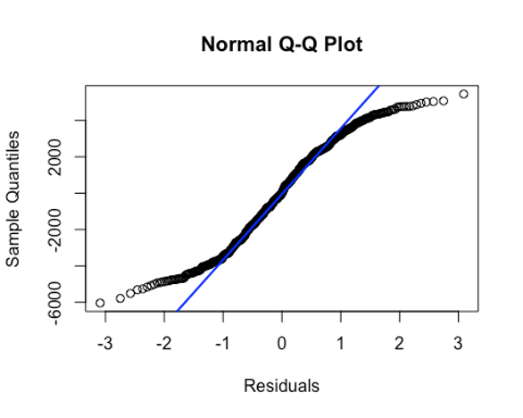
Figure 3: Combined Model QQ Plot of Residuals
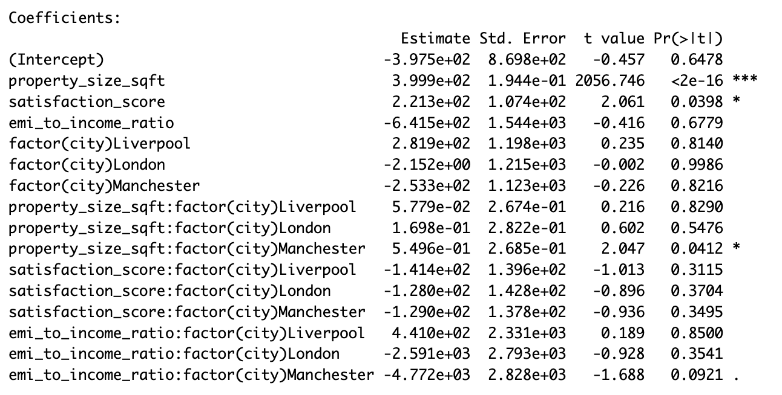Figure 4: Initial Combined Model Summary
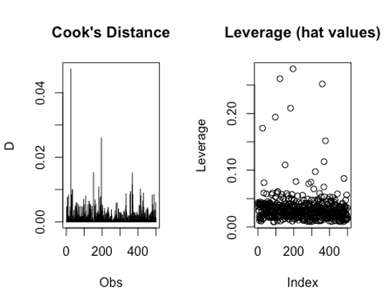
Figure 5: Cook’s Distance and Leverage plots for Initial Combined Model
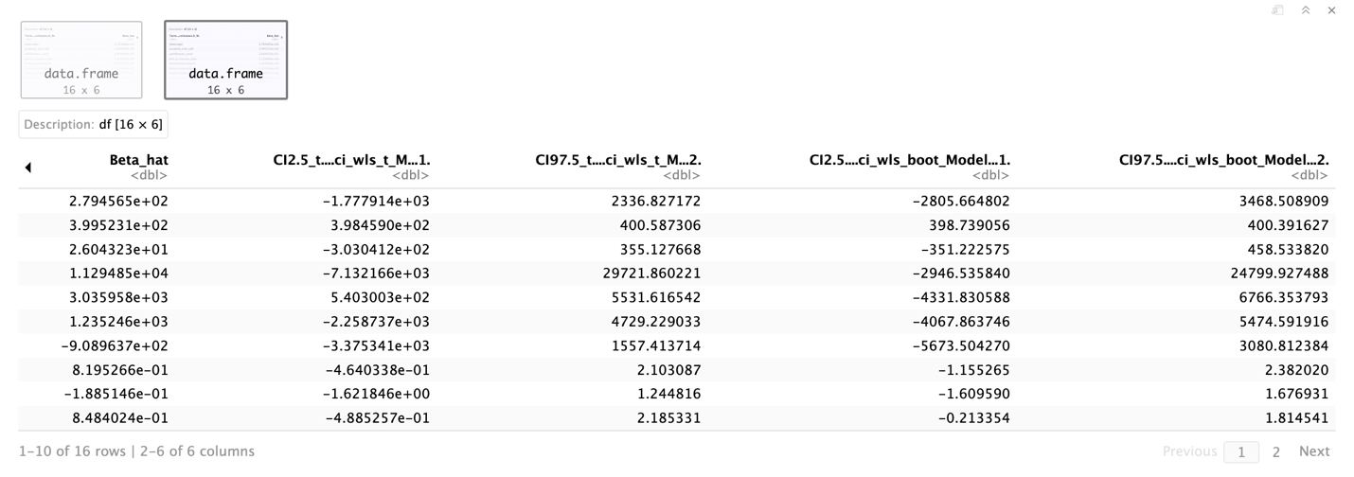Figure 6: WLS Bootstrapped Confidence Intervals
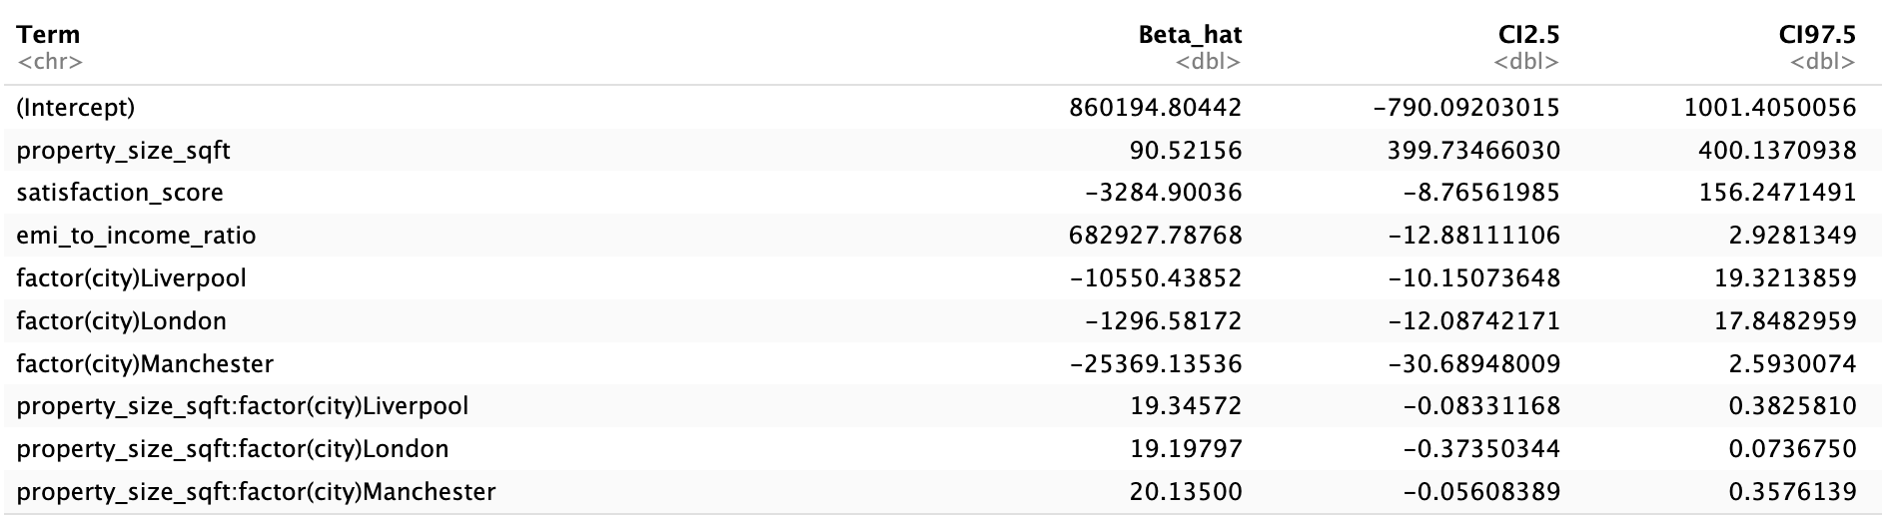Figure 7: Ridge Regression Bootstrapped Confidence Intervals 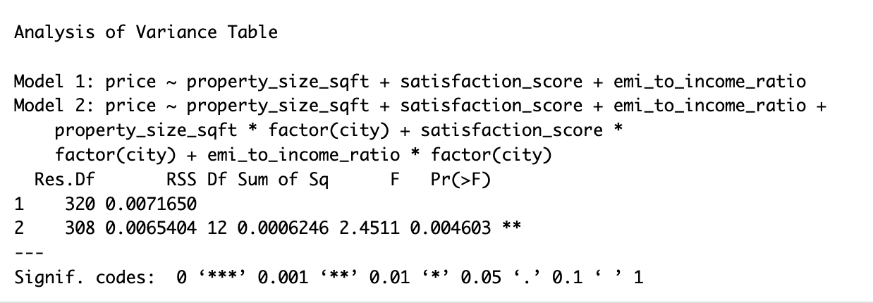Figure 8: ANOVA output for Combined Model

REFERENCES
Aliyev, K., Amiraslanova, M., Bakirova, N., & Eynizada, N. (2019). Determinants of housing prices in Baku: empirical analyses. International Journal of Housing Markets and Analysis, 12(2), 281–297. https://doi.org/10.1108/ijhma-08-2018-0062
Bohman, H. (2021). Same, same but different? Neighbourhood effects of accessibility on housing prices. Transport Policy, 107, 52–60. https://doi.org/10.1016/j.tranpol.2021.04.016

